# Overview

One of the common uses for group policy is to redirect common folders to a network location. This is often done instead of roaming profiles, to allow users access to their documents no matter what computer they use. This also allows network administrators to easily backup user files.

# Objectives

* Be able to configure common group policy settings

# Prerequisites

* Guided practice – Creating **Active Directory Objects** is complete
* Verify that the \\ABSDC1\Redirect share exists on **ABSDC1**.
* Verify that the \\CHDC\Redirect share exists on **CHDC**.

# Scenario

Your organization is interested in centralizing the management of user and computer settings. It would like to do this using **Active Directory** and **Group Policy**. They would like you to test out the operation of **Group Policy** in the guided practice so that you can later provide a plan for using **Group Policy** to manage user and computer settings.

# Tasks

## Setup

**!!!Note!!!**

Before configuring any additional group policies, remove all the settings you used to enforce and block inheritance of group policy in previous guided practices.

## Creating a Folder Redirection policy

To redirect a folder to a network location, you will need a shared folder to store the folders that are redirected. You will also need to know the UNC path to the shared folder. In a previous guided practice, you created a shared folder named redirect on the **CHDC**, and **ABSDC1** servers.

Create a group policy to redirect the documents and desktop folders for users in the Greenville location by performing the following:

1. Login to the **CIS256-DC1** virtual machine using an **ABSAdmin**.
2. Open the **Group Policy Management** console.
3. Create a new **GPO** named **Greenville Folder Redirection** in the **Group Policy Objects** container.
4. Edit the **Greenville Folder Redirection** policy as follows:
   1. Browse to the **User Configuration → Policies → Windows Settings → Folder Redirection** node.
   2. 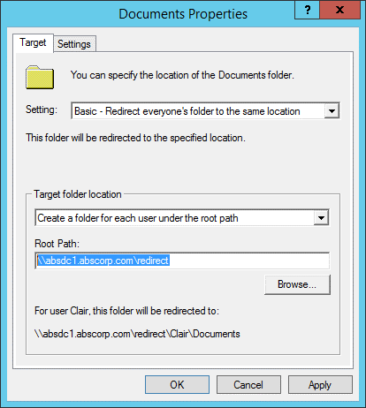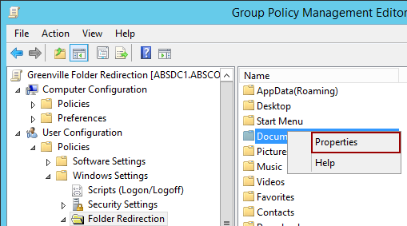Right-Click the **Documents** folder and select **Properties** from the context menu as shown in the figure below.
   3. In the **Documents Properties** dialog box configure the following:
      1. Setting: **Basic – Redirect everyone’s folder to the same location**
      2. Target Folder Location: **Create a folder for each user under the root path**
      3. Root path: **\\absdc1.abscorp.com\redirect**
      4. The configurations are shown in the figure to the right.
      5. Select the **Settings** tab and view the **other settings** that can be applied. Leave the settings and close the **dialog** box**.**
      6. Repeat the procedure above to redirectthe **Desktop folder** to the same location.
5. Create another **GPO** named **Charlotte Folder Redirection** that **redirects** the **Documents** and **Desktop** folders to the **Redirect** **share** on **CHDC.**
6. Link the **Greenville Folder Redirect** policy to the **Greenville OU** and the **Charlotte Folder Redirect** policy to the **Charlotte OU.**

## Adjust the Redirect folder Permissions

Users will need to create a folder in the **Redirect** share but they only have read and execute permissions. You need to grant them permission to **Create folders and Append data** in the redirect folder. To do this perform the following:

1. Login to the **CIS256-DC1** virtual machine
2. 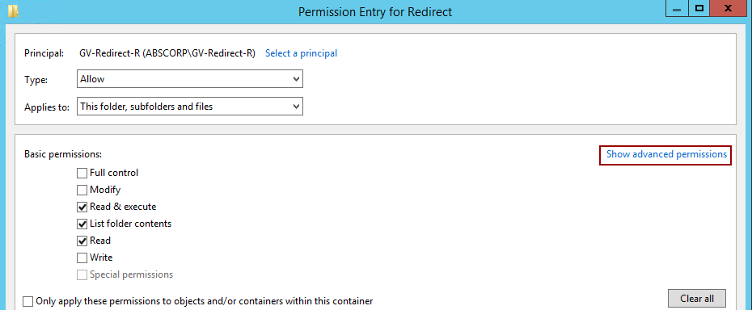Open the **Security** tab for the **C:\Shares\Redirect** folder.
3. Click the **Advanced** button.
4. Double-click the **ABSDC1-Redirect-R** group and then click the **Show advanced permission**s link as shown in the figure.
5. Select the **Create files / Write data** and **Create Folders / Append** **data** options and then **click** the **OK** button.
6. Click the **OK** button again to exit the dialog.
7. Repeatthis process on the redirect share on **CHDC** (CIS256-DC2)
8. **Reset** the **passwords** for **Cody Decker** and **Diana Green** to **Password1**. They will be used to test folder redirection.

## Verify the folder redirection policy

1. Login to the **CIS256-Client1** virtual machine as a user **Cody Decker** (codecker) from **Greenville**.
2. Open **File Explorer.**
3. 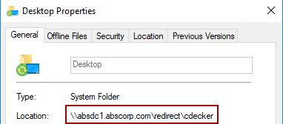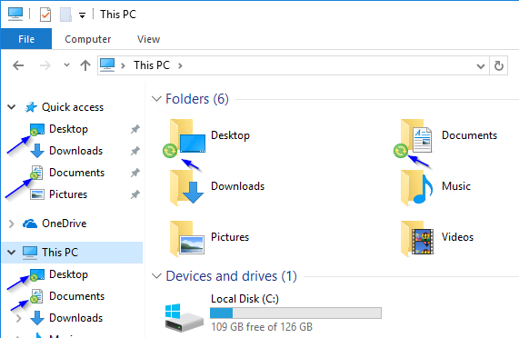You should now see a small icon next to the redirected folders as shown in the figure below.
4. To verify the path, right-click on one of the redirected folders and select properties from the context menu. The **Location:** property should show where the folder is located.
5. Create a **text** file named **Desktop** on the **Desktop** and a **text** file named **Documents** in the **Documents** folder.
6. You should see a copy of these files in the shared folder on the server with the shared folder
7. Login to the **CIS256-Client2** virtual machine as user **Diana Green** (digreen) from **Charlotte**.
8. Verify the folders were redirected.
   1. If the folders are not redirected, you may have to force replication between sites and then logoff and log back on as **digreen**. This is
9. Create a text file named **Desktop** on the **Desktop** and a text file named **Documents** **in** the **Documents** folder.

## Submission requirements

1. **Download** the **grading** **script** from the assignment page to the **C:\Scripts** folder.
2. Check your lab by running the following command:

Invoke-Pester -Path C:\Scripts\GP16-Redirecting_Folders_ with_Group_Policy.test.ps1

**Note**: You will see a security warning when running the script. Enter **R** to run the script.

If you want to see more detail, add **-Output Detailed** to the command. This may assist you with troubleshooting

Invoke-Pester -Path C:\Scripts\GP16-Redirecting_Folders_ with_Group_Policy.test.ps1 -Output Detailed

1. You should not see any red in the output. Red in the PowerShell way of telling you that an error condition exists. Most of the time, the output will tell you what is wrong. If it is not obvious, contact your teacher and ask for assistance. You will be learning PowerShell during this term. **Correct** any **errors** you may have and run the script until all the output has no red. You should see the output like the images below:

1. Capture a snippet that shows the PowerShell Command and all its output. If you must use more than one snippet to capture the output, you must have at least **one line of overlap** in the snippets. The text in the snippets **must be legible** when pasted into the Word document. Paste the snippet(s) into a **new** **Word** **document.** Save the file as **Redirect_*Firstname*_*LastName*** (where ***Firstname*** is your first name and ***Lastname*** is your last name).
2. **Upload** the **document** in the submission area of the assignment.